WEEK 3 – SOFTWARE ENGINEERING PRINCIPLES

Last Lecture

- Overview of C-portions of C++ Languages

Outline of Today’s Lecture

- Software Design Process
- Software development cycle
- Quality of software
- Software design methodologies

UNIT 1: SOFTWARE DESIGN PROCESS

Main Objective: Overview of software design steps and methodologies in software engineering

Background information

What is software engineering?
- Software Engineering
- A disciplined approach to the design, production, and maintenance of computer programs that are developed on time and within cost estimates
- Engineering
- Creates cost-effective solutions to practical problems by applying scientific knowledge to building things in the service of humankind
- Software Engineering
- The things contain software
- But:
- Pure software is useless
- Software exists only as part of a system
- Software is invisible, intangible, abstract
- There are no physical laws underlying software behavior
- There are no physical constraints on software complexity
- Software never wears out
- Traditional reliability measures don’t apply
- Software can be replicated perfectly
- No manufacturing variability

Why is software engineering important ?
- Software becomes more expansive than hardware
- In 2000, software accounted for 80% of budget and hardware only 20%. Before 1960, these numbers were just opposite.

- Software development problems lead to high cost
- Low productivity
- Programmers average 10 to 15 debugged lines of code per day
- Reputation for being unreliable
- Programs are hard to maintain

- Possible causes
- Programmers are spread too thin
- Lack of standardized approach to program design
- Lack of concern for maintenance

- Possible solution
- Structured programming
- Use of libraries (code and classes)
- Use of teams
- Software engineering (systematical )

- Software sizing
- Trivial programs
- Single programmer
- One to four weeks to complete
- About 500 lines of code
- You don’t need worry about anything except coding
- Large program
- Five to 20 programmers
- One to two years to complete
- 50,000 to 100,000 lines of code
- Window 98 had over 20 (?) lines of code !
- You need to be concerned about many things in such environment and the software development becomes a kind of complex life cycle

?

Software development cycle

Life Cycle of Software Development

Feasibility study
- Is it cost effective to develop a computer-based solution for this problem ?
- Problem specification phase
- Transform customer request into an unambiguous statement (make them say what they mean in clear terms)
- Problem design phase
- functional decomposition (structural approach)
- List of every module in proposed solution
- Relationships among components (calling)
- Interface specifications
- Description of module actions/effects
- Object-oriented approach
- Hierarchical tree of classes
- Relationships among classes
- Attributes of each class
- Operations of each class
- Module design
- Selecting algorithm
- Selecting data type
- ADT
- Regular data type
- Coding
- Select target language and implement

- Debugging
- Remove compilation errors
- Find design defects
- Testing and verification
- Test data
- Formal verification (proof)
- Documentation
- Programming maintenance

- What is relationship among the above stages ?

Typical time allocation
- Specification/design/planning (30% to 40%)
- Coding (15% to 20%)
- Testing/verifying/fixing (30% to 40%)
- Documentation (10% to 15%)

?

Main Objective of Software Development
- Create a profitable product in market by providing a high-quality software

Software Quality

Efficiency and reliability: It works efficiently and reliably

Clarity: It should be able to be read and understood

Modifiability and maintainability: It can be modified without excruciating time and effort

Availability and affordability: It should be completed on time and within budget

In order to produce high-quality software, people in the past used different methodologies available in software engineering

Software Design Methodologies

- One strategy for software design
- Abstraction: to model a complex system you include only the details essential to the perspective of the viewer of the system
- Example

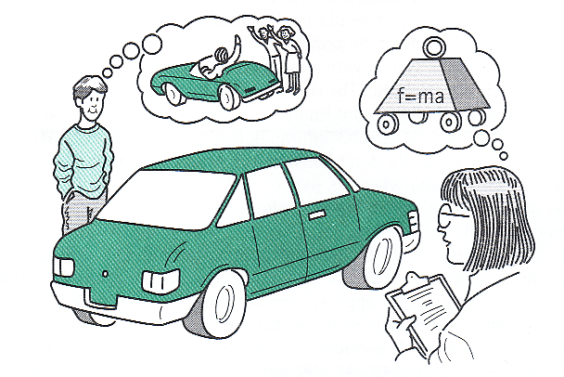
- Effect of abstraction
- Information hiding: you may hide the details of a function or data structure with the goal of controlling access to the details of a module or data structure
- example

Two main design methodologies
- Functional decomposition ← abstraction of functionality
- Object-oriented design ← abstraction of data structure
- Why ?
- Programming languages

Functional Decomposition
- Use the divide-and-conquer technique (?) to decompose functionality
- Example (FEM)
- It is a top-down approach to break an entire task into a number of subroutines
- Example

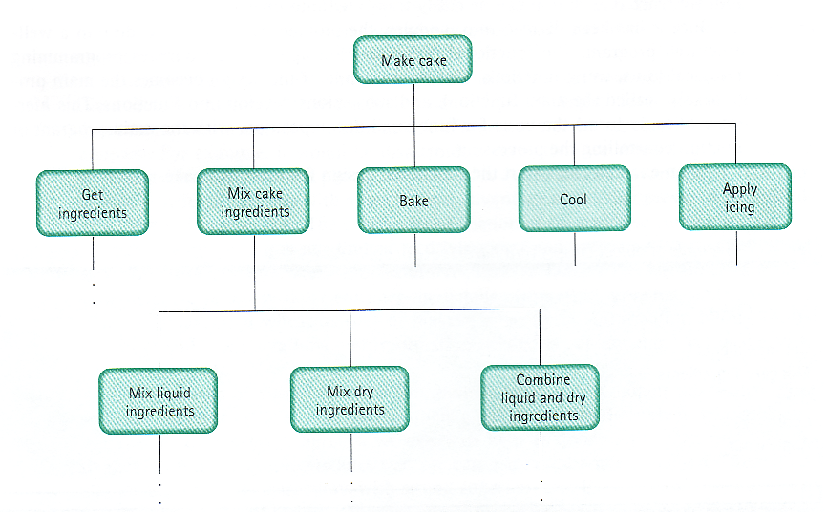

- Object-oriented design
- Software design is carried out around the center of object classes (?)
- Example

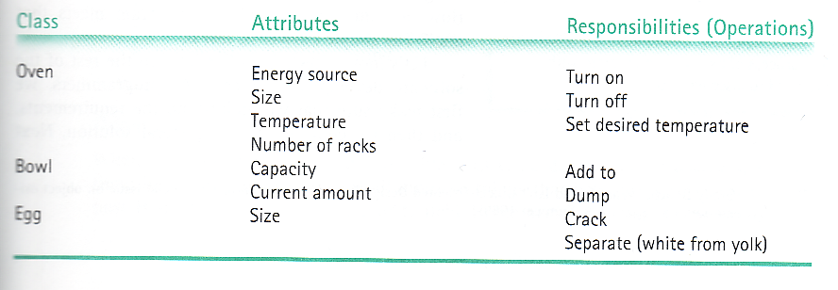

- How to use these two methodologies
- Small problems
- Functional decomposition
- Medium-sized problems
- A combination of functional decomposition and object-oriented design
- large problems
- object-oriented design

?

Today’s Lecture

- Software design process
- Life cycles
- quality
- Design methodologies

Next Lecture

- Software Verification
UNIT 2: SOFTWARE VERIFICATION

Last Lecture

- Software design process
- Life cycles
- quality
- Design methodologies

Today’s Lecture

- Software Verification
- I/O in C++

Software Verification

- a process of determining the degree to which a software product fulfills its specifications

SPECIFICATIONS

Inputs

Outputs

Processing
Requirements

Assumptions

PROGRAM

Verification vs. Validation

Program verification asks,
“Are we doing the job right?”

Program validation asks,
“Are we doing the right job?”

B. W. Boehm, Software Engineering Economics, 1981.

Program Testing

- Testing is the process of executing a program with various data sets designed to discover errors

DATA SET 1
DATA SET 2

DATA SET 3

DATA SET 4

. . .

Keyboard and Screen I/O

#include <iostream.h>

output data
input data
Screen
executing
program
Keyboard

cin

(of type istream)
cout

(of type ostream)

<iostream.h> is header file

- for a library that defines 3 objects

- an istream object named cin (keyboard)

- an ostream object named cout (screen)

- an ostream object named cerr (screen)

Insertion Operator ( << )

- The insertion operator << takes 2 operands.

- The left operand is a stream expression, such as cout.

- The right operand is an expression describing what to insert into the output stream. It may be of simple type, or a string, or a manipulator (like endl).

Extraction Operator ( >> )

- Variable cin is predefined to denote an input stream from the standard input device ( the keyboard ).

- The extraction operator >> called “get from” takes 2 operands. The left operand is a stream expression, such as cin. The right operand is a variable of simple type.

- Operator >> attempts to extract the next item from the input stream and store its value in the right operand variable.

- “skips” (reads but does not store anywhere)
leading whitespace characters
(blank, tab, line feed, form feed, carriage return)
before extracting the input value from the stream (keyboard or file).

- To avoid skipping, use function get to read the next character in the input stream.
cin.get(inputChar);
#include <iostream.h>

int main( )
{ // USES KEYBOARD AND SCREEN I/O
int partNumber;
float unitPrice;

cout << “Enter part number followed by return : “
<< endl ; // prompt
cin >> partNumber ;
cout << “Enter unit price followed by return : “
<< endl ;
cin >> unitPrice ;
cout << “Part # “ << partNumber // echo
<< “at Unit Cost: $ “ << unitPrice << endl ;
return 0;
}

Disk files for I/O

#include <fstream.h>

input data
output data

disk file
“A:\myInfile.dat”
disk file
“A:\myOut.dat”
executing
program

your variable

(of type ifstream)
your variable

(of type ofstream)

- use #include <fstream.h>
- choose valid variable identifiers for your files and declare them

- open the files and associate them with disk names

- use your variable identifiers with >> and <<

- close the files
Statements for using file I/O

#include <fstream.h>

ifstream myInfile; // declarations
ofstream myOutfile;

myInfile.open(“A:\\myIn.dat”); // open files
myOutfile.open(“A:\\myOut.dat”);

myInfile.close( ); // close files
myOutfile.close( );

- What does opening a file do?

- associates the C++ identifier for your file with the physical (disk) name for the file

- if the input file does not exist on disk, open is not successful

- if the output file does not exist on disk, a new file with that name is created (?)

- if the output file already exists, it is erased (?)

- places a file reading marker at the very beginning of the file, pointing to the first character in it

?
#include <fstream.h>

int main( )
{ // USES FILE I/O
int partNumber;
float unitPrice;
ifstream inFile; // declare file variables
ofstream outFile;

inFile.open(“input.dat”); //open files
outFile.open(“output.dat”);

inFile >> partNumber ;
inFile >> unitPrice ;
outFile << “Part # “ << partNumber // echo
<< “at Unit Cost: $ “ << unitPrice << endl ;
return 0;
}
Stream Failure

- When a stream enters the fail state, further I/O operations using that stream are ignored. But the computer does not automatically halt the program or give any error message.

- Possible reasons for entering fail state include:
- invalid input data (often the wrong type),
- opening an input file that doesn’t exist (?),
- opening an output file on a diskette that is already full or is write-protected.

?
#include <fstream.h>
#include <iostream.h>

int main( )
{ // CHECKS FOR STREAM FAIL STATE
ifstream inFile;
inFile.open(“input.dat”); // try to open file
if ( !inFile )
{
cout << “File input.dat could not be opened.”;
return 1;
}
. . .
return 0;
}
Various Types of Errors

- Design errors occur when specifications are wrong

- Compile errors occur when syntax (?) is wrong

- Run-time errors result from incorrect assumptions, incomplete understanding of the programming language, or unanticipated user errors.

?
Robustness

- Robustness is the ability of a program to recover following an error; the ability of a program to continue to operate within its environment.

An Assertion

- Is a logical proposition that is either true or false (not necessarily in C++ code).

EXAMPLES
studentCount is greater than 0

sum is assigned && count > 0

response has value ‘y’ or ‘n’

partNumber == 5467
Preconditions and Postconditions

- The precondition is an assertion describing what a function requires to be true before beginning execution.

- The postcondition describes what must be true at the moment the function finishes execution.

- The caller is responsible for ensuring the precondition, and the function code must ensure the postcondition.

Example

?
void PrintList ( ofstream& dataFile, UnsortedType list)
// Pre: list has been initialized.
// dataFile is open for writing.
// Post: Each component in list has been written to dataFile.
// dataFile is still open.
{ using namespace std;
int length;
ItemType item;

list.ResetList();
length = list.LengthIs();
for (int counter = 1; counter <= length; counter++)
{
list.GetNextItem(item);
item.Print(dataFile);
}
}
Another Example

void Getroots (float a, float b, float c,
float& root1, float& root2 )
// Pre: a, b, and c are assigned.
// a is non-zero, b*b - 4*a*c is non-zero.
// Post: root1 and root2 are assigned
// root1 and root2 are roots of quadratic with coefficients a, b, c
{
float temp;
temp = b * b - 4.0 * a * c;
root1 = (-b + sqrt(temp) ) / ( 2.0 * a );
root2 = (-b - sqrt(temp) ) / ( 2.0 * a );
return;
}
Verification Methods

- Walk-through

- Is a verification method using a team to perform a manual simulation of the program or design, using sample test inputs, and keeping track of the program’s data by hand.

- Its purpose is to stimulate discussion about the programmer’s design or implementation



- Inspection

- A verification method in which one member of a team reads the program or design line by line and the others point out errors

Program Testing

- Unit testing

- Integration testing

- Black-box testing
- Testing a program or function based on the possible input value, testing the code as a black box

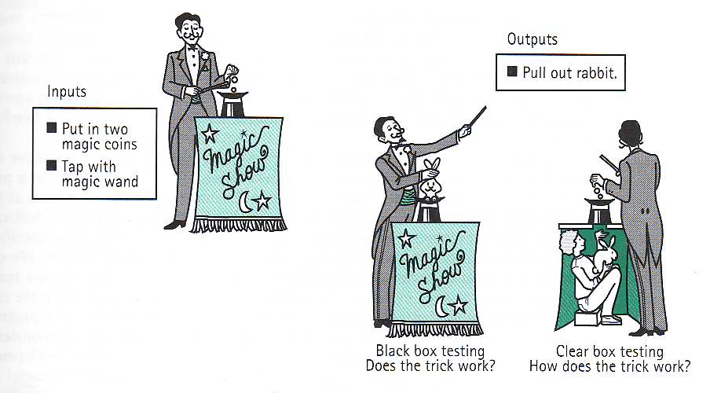

- Metric-based testing
- Testing based on measurable factors (e.g. 80% branch coverage)

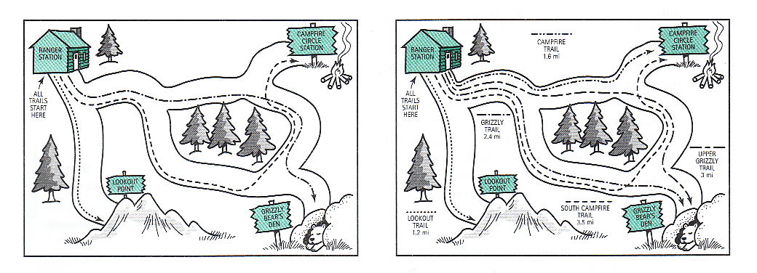

Tasks within each test case:

- determine inputs that demonstrate the goal.

- determine the expected behavior for the input.

- run the program and observe results.

- compare expected behavior and actual behavior. If they differ, we begin debugging.

Integration Testing

- Is performed to integrate program modules that have already been independently unit tested.

Main

Find
Weighted
Average
Print
Weighted
Average
Print Data

Get Data
Prepare
File for
Reading

Print Heading

Integration Testing Approaches

TOP-DOWN

(start in Main f(x))
Ensures correct overall design logic.

*make stub functions
*stub = shell function

USES: placeholder module “stubs” to test the order of calls

BOTTOM-UP

(test sub functions; classes)
Ensures individual modules work together correctly,
beginning with the
lowest level.
*these are the real functions tested
USES: a test driver to call the functions being tested

Top-Down Testing

- Key idea
At each level of testing, the top-down approach is based on the assumption that the lower levels work correctly, so they can be replaced by stubs

- Stub
A special function that can be used in top-down testing to substitute a lower-level function

- Example
A program FractionCalc, which reads in operation commands and pairs of values of type FractionType (numerator and denominator), execute the appropriate operation on them, and print the result.

Top level

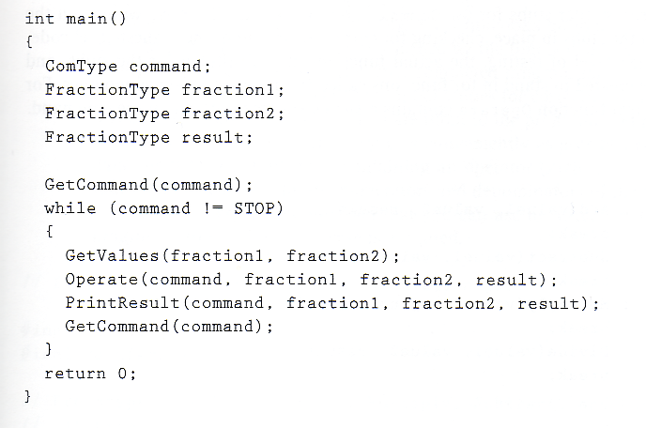
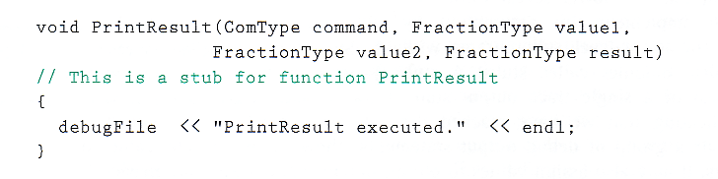
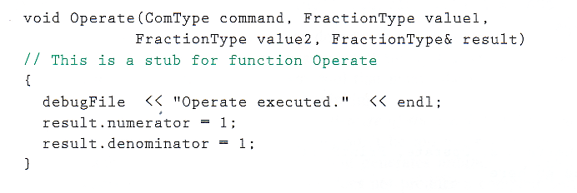

- Second level

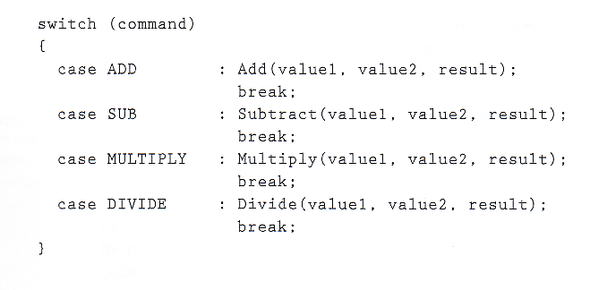
- Third level (lowest)
Full implementation of add(), subtract(), multiply() and divide().

Bottom-Up Testing

- Key idea
Test the lowest-level subprograms first, which are likely not influenced by a team work. The test is carried out by using test drivers (i.e., a simple main function() used to test that particular low-level function)

- Test driver
A program that sets up the testing environment by declaring and assigning initial values to variables, then calls the subprogram to be tested

- Example
A program FractionCalc, which reads in operation commands and pairs of values of type FractionType (numerator and denominator), execute the appropriate operation on them, and print the result.
- First level

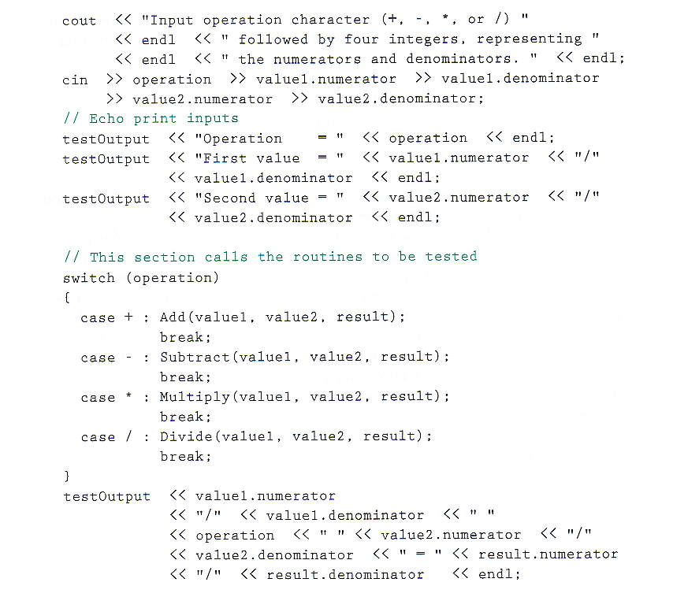

Today’s Lecture

- Software Verification
- Top-down testing
- Bottom-up testing
- I/O in C++

Next Lecture

- Object-oriented Design

